ONE SQUARE METER
BY DANTATA

PROPERTY PORTFOLIO
Comprehensive Guide to All Properties & Investment Opportunities
Dantata Hostels · Dantata Vistas · Dantata Arcade
Effective February 2026 | Abuja, Nigeria

3  Property Lines | 6  Abuja Locations | 35%+  Capital Growth p.a. | 100%  Target Occupancy

ABOUT 1SQM BY DANTATA
Founded in 1976 · Dantata & Sawoe Consortium

1SQM by Dantata is a fractional real estate platform operated by the Dantata & Sawoe Consortium, one of Nigeria's most storied construction and development groups. The platform democratises access to premium Abuja real estate by allowing investors to own high-quality residential and commercial units at multiple price points — from student co-living hostels to premium detached duplexes and commercial arcades.

Every property in the 1SQM portfolio is designed and delivered to the highest construction standards, drawing on decades of expertise in Nigerian real estate. Units are available at various build stages — DPC, Shell, Advanced Shell, or Fully Furnished — giving investors flexibility to enter at the most financially strategic point.

The company's investment thesis is straightforward: Abuja is a high-growth, supply-constrained market with strong formal-sector demand. Pairing that fundamentally robust market with purpose-built design, professional management, and transparent pricing creates assets that deliver both reliable rental income and above-market capital appreciation.

Headquarters | Abuja, Federal Capital Territory, Nigeria
Contact | 0902 002 0077 · 1sqmbydantata.com
Payment Bank 1 | Providus Bank · Account: 1300778295 (ONE SQUARE METER)
Payment Bank 2 | Zenith Bank · Account: 1015923218 (ONE SQUARE METER — Vistas 2151 only)
Established | 1976 — Dantata & Sawoe Consortium
Portfolio | Dantata Hostels · Dantata Vistas (002, 106, 310, 2151) · Dantata Arcade

DANTATA HOSTELS
Plot 747 · Nile–Baze University Corridor · Jabi, Abuja

INVESTMENT OVERVIEW

Dantata Hostels is a purpose-built student co-living investment in the heart of the Nile–Baze University Corridor in Jabi — Nigeria's most concentrated academic district. With a 20,000+ student catchment and virtually zero vacancy, the development targets the most resilient segment of the Nigerian rental market: premium student accommodation.

Every unit is delivered fully furnished and rent-ready. Units come with durable student beds, study desks, wardrobes, fitted kitchen cabinets, and living room furniture — enabling rental income from day one. The development features on-site recreation facilities, a Tech Innovation Hub, professional security, and modern power infrastructure.

Location | Plot 747, Cadastral Zone C00, Institution & Research District, Jabi, Abuja
Target Market | Premium student accommodation — Nile & Baze University corridor
Student Population | 20,000+ students within immediate catchment
Annual Rental Yield | 12% – 15% per annum
Capital Appreciation | 35%+ per annum
Target Occupancy | 99.9% — demand-driven, virtually zero vacancy
Unit Delivery | Fully furnished and rent-ready from day one
Payment Bank | Providus Bank · 1300778295 · ONE SQUARE METER BY DANTATA LTD
Application Form | 747 Application Form.pdf — in document folder

Why Student Accommodation in Jabi?

Student accommodation consistently outperforms conventional residential rentals in Nigeria's capital. The academic calendar creates reliable, recurring demand — beds are let before the previous tenants vacate. The Jabi corridor is unique: it is the only part of Abuja where two internationally recognised universities (Nile and Baze) create an overlapping demand zone, effectively doubling the catchment relative to a single-university location. Premium student demand also means tenants pay higher rents for quality, reducing price sensitivity and enabling management to maintain premium specifications.

Amenities

- Recreation Facilities — social and leisure spaces for residents
- Tech Innovation Hub — dedicated co-working and computing suite
- Managed Infrastructure — centralised facility management with maintenance protocols
- Professional Security — 24/7 security personnel and CCTV coverage
- Modern Power Solutions — reliable power supply with backup generation
- 12-Month Payment Plan — flexible instalment schedule for investors

4 BEDROOM TERRACE DUPLEX — HOSTEL 747 | From ₦300,000,000

The flagship hostel unit: a fully furnished four-bedroom terrace duplex accommodating 8 student bedspaces across two floors. Combining maximum bedspace density with premium specifications, this is the highest-yielding unit type in the Hostels portfolio. The ground floor houses a common living area and fitted kitchen; the first floor delivers four private en-suite bedrooms, each furnished with a student bed, study desk, and wardrobe.

Bedrooms / Bedspaces | 4 bedrooms · 8 bedspaces
Bathrooms | 4.5 (en-suite per bedroom + guest WC)
Floors | Ground floor + First floor
Furnishing | Fully furnished — beds, desks, wardrobes, kitchen, living room
Property Value | From ₦300,000,000
Annual Rental Income | ₦32,000,000 (projected)
Gross Rental Yield | ~10.7% at launch price
Capital Appreciation | 35%+ per annum
Income per Bedspace | ₦4,000,000 per bedspace per annum

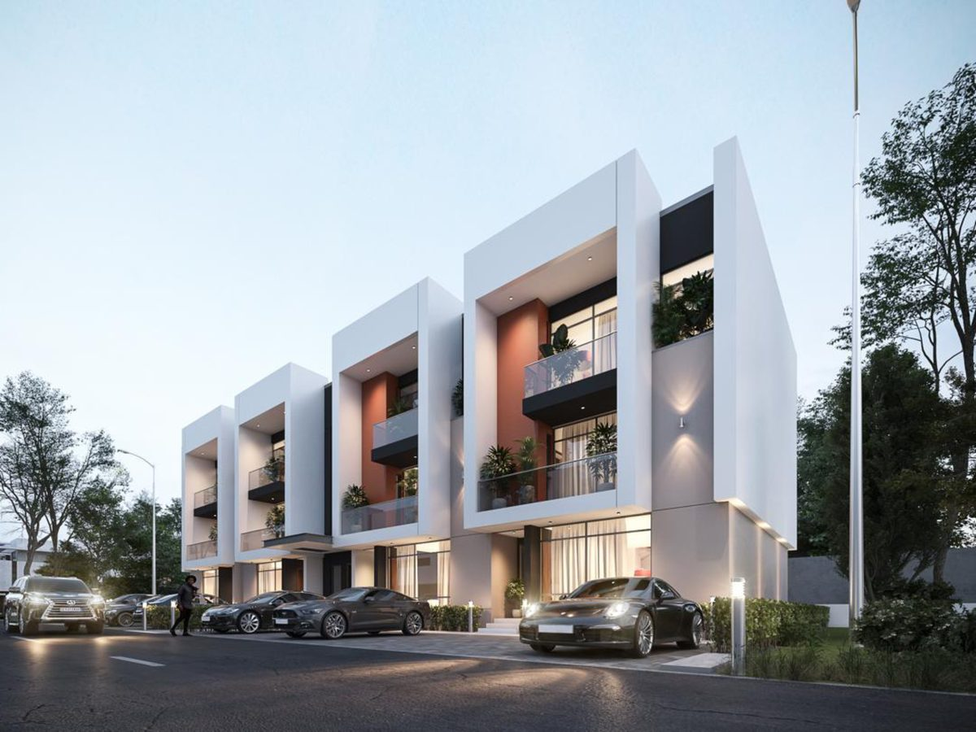
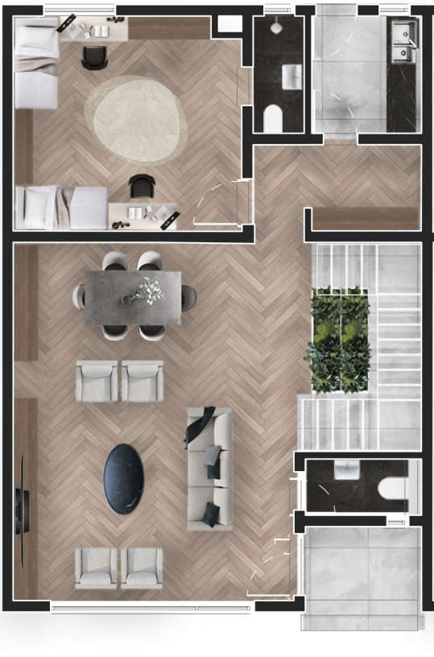 |  | 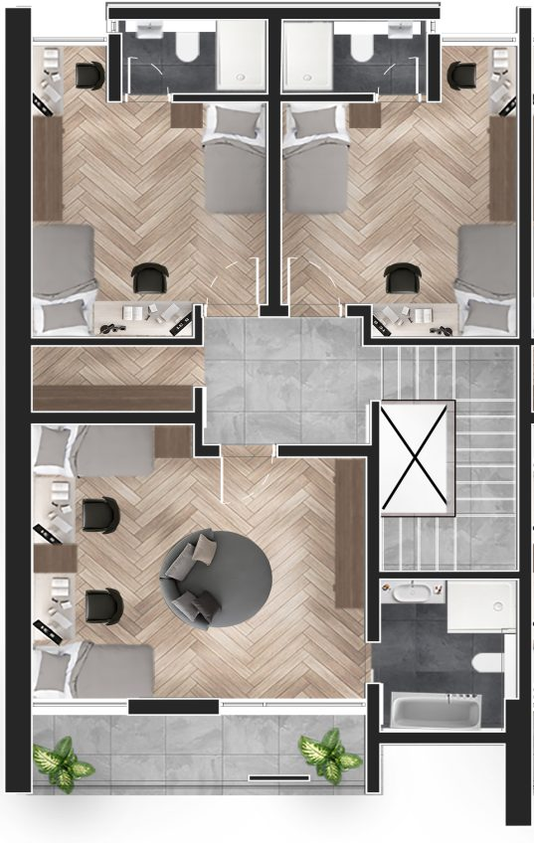
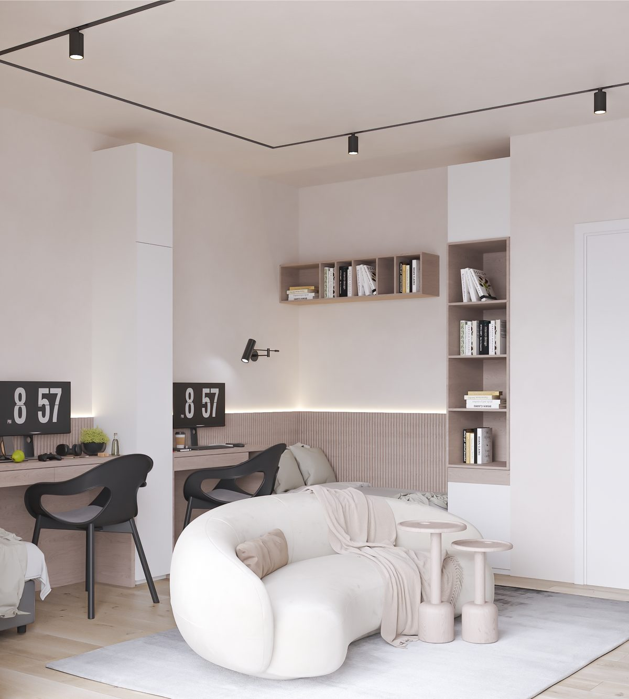

3 BEDROOM TERRACE DUPLEX — HOSTEL 747 | From ₦225,000,000

A lower-capital entry point while still delivering compelling student rental returns. Six bedspaces across two floors serve a slightly smaller group, with the same premium specification as the four-bedroom unit. Well-suited for investors who want strong yield with a more accessible capital commitment, or who wish to build a portfolio of multiple units over time.

Bedrooms / Bedspaces | 3 bedrooms · 6 bedspaces
Bathrooms | 3.5 (en-suite per bedroom + guest WC)
Floors | Ground floor + First floor
Furnishing | Fully furnished
Property Value | From ₦225,000,000
Annual Rental Income | ₦24,000,000 (projected)
Gross Rental Yield | ~10.7% at launch price
Capital Appreciation | 35%+ per annum

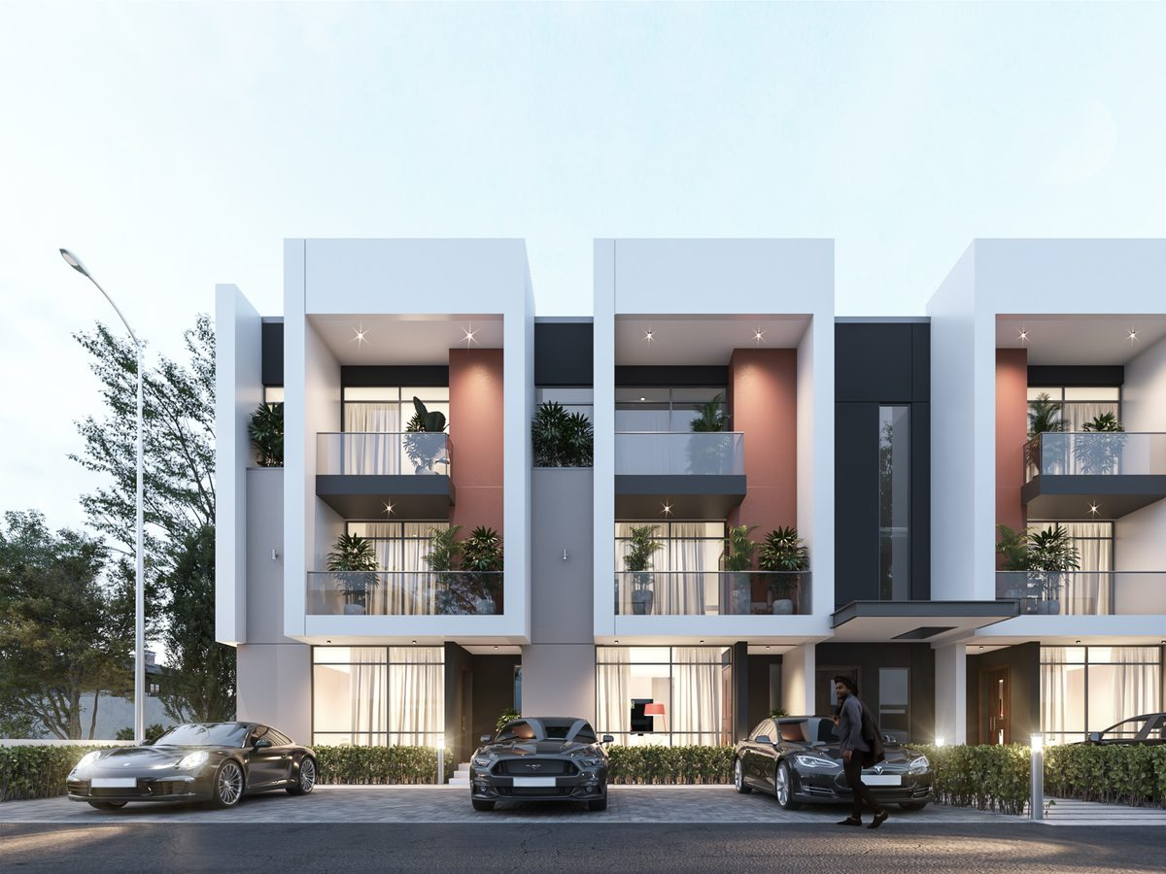
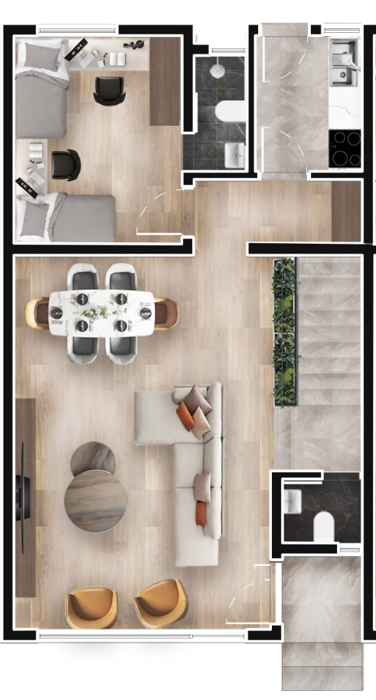 |  | 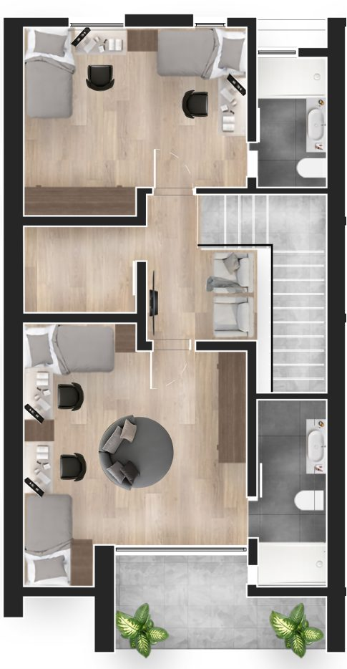
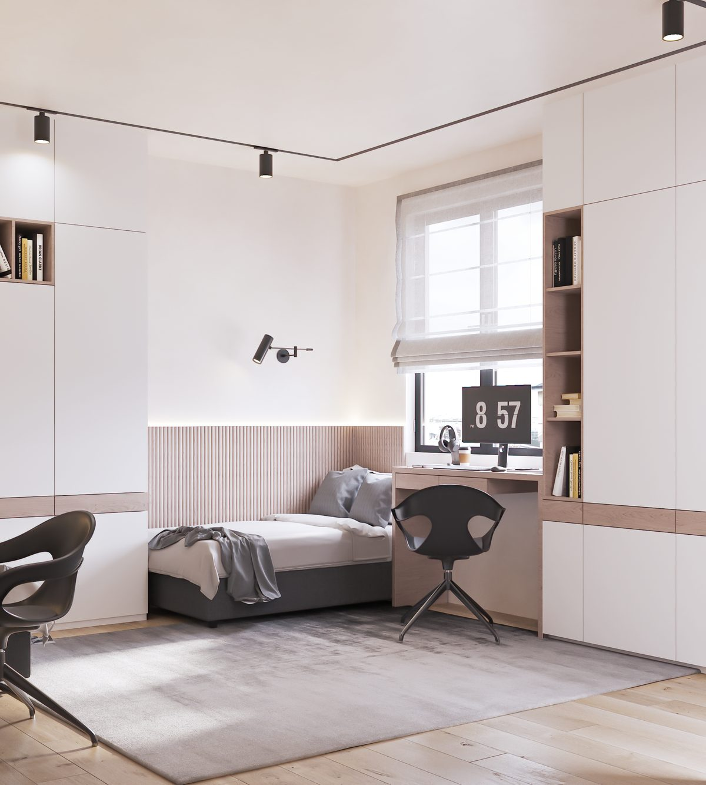

2 BEDROOM APARTMENT — HOSTEL 747 | From ₦150,000,000

The most accessible entry point into the Hostels programme. Four bedspaces on a pent-floor configuration. The apartment format appeals particularly to postgraduate and international students who pay a premium for privacy. Fully furnished and rent-ready from day one, with the same delivery specification as the terrace units.

Bedrooms / Bedspaces | 2 bedrooms · 4 bedspaces
Bathrooms | 2.5 (en-suite per bedroom + guest WC)
Configuration | Pent floor apartment
Furnishing | Fully furnished
Property Value | From ₦150,000,000
Annual Rental Income | ₦16,000,000 (projected)
Gross Rental Yield | ~10.7% at launch price
Capital Appreciation | 35%+ per annum



1 BEDROOM APARTMENT — HOSTEL 747 | ₦112.5M (Gold) · ₦115M (Platinum)

The entry-level Hostel unit offers three bedspaces on the pent floor despite its smaller footprint, delivering the same robust rental yield. Two pricing tiers — Gold and Platinum — offer flexibility based on floor level and aspect. Available in three sub-types (A, B, C) reflecting different floor-plan configurations within the same building footprint.

Bedrooms / Bedspaces | 1 bedroom · 3 bedspaces
Bathrooms | 1.5 (en-suite + guest WC)
Configuration | Pent floor · Types A, B, or C
Furnishing | Fully furnished
Price (Gold) | ₦112,500,000
Price (Platinum) | ₦115,000,000
Annual Rental Income | From ₦12,000,000 (projected)
Payment Option | 12-month payment plan available

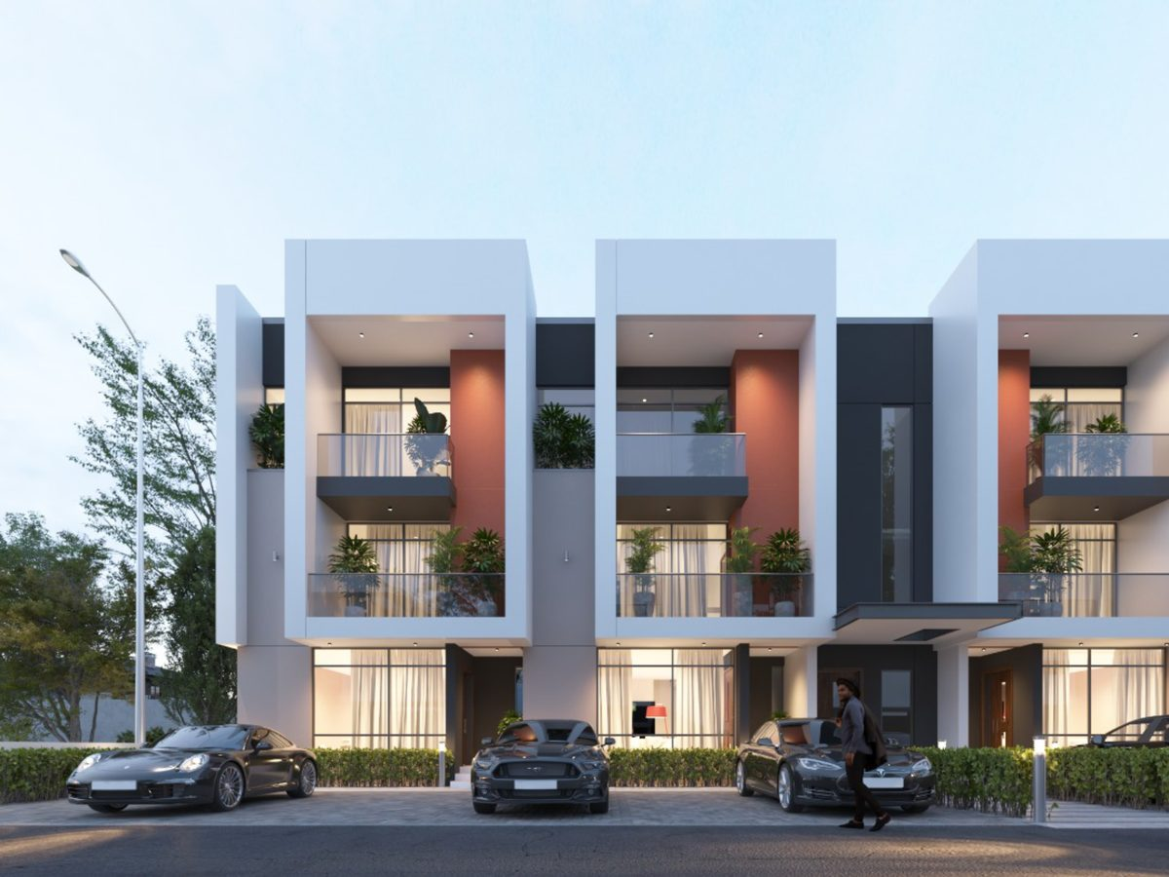

Hostel Unit Comparison

Unit Type | Bedspaces | Bathrooms | Price | Annual Income | Yield
4 Bed Terrace Duplex | 8 | 4.5 | ₦300,000,000 | ₦32,000,000 | ~10.7%
3 Bed Terrace Duplex | 6 | 3.5 | ₦225,000,000 | ₦24,000,000 | ~10.7%
2 Bed Apartment | 4 | 2.5 | ₦150,000,000 | ₦16,000,000 | ~10.7%
1 Bed Apt (Gold) | 3 | 1.5 | ₦112,500,000 | ₦12,000,000 | ~10.7%
Studio Apartment | — | 1.0 | ₦50,000,000 | — | —

DANTATA VISTAS
Four Premier Residential Developments Across Abuja

PORTFOLIO OVERVIEW

Dantata Vistas is the residential development arm of the 1SQM portfolio — a collection of four strategically located projects across Abuja's most sought-after growth corridors. Each project offers a consistent range of unit typologies (4-bedroom detached duplexes with BQ, 4-bedroom terrace duplexes, 3-bedroom and 2-bedroom apartments) at varying price points reflecting their distinct locations.

The Vistas portfolio offers exceptional investment flexibility: from early-stage DPC entry at Vistas 2151 from just ₦65M, through to advanced shell units in Jabi's premier residential belt. All four projects are delivered by the same construction team to the same quality standard — it is the location that differentiates price and appreciation potential.

Vistas 002 | EFAB Queens, Karsana — 4 Bed Detached Duplex
Vistas 106 | Papal's Ground, Karsana North — Full range from ₦77M
Vistas 310 | Nile University Street, Jabi — Premium location, from ₦83M
Vistas 2151 | By Kabusa Gardens, Lokogoma — Entry from ₦65M (DPC stage)

VISTAS 002 — EFAB QUEENS, KARSANA

Vistas 002 occupies a site within the prestigious EFAB Queens development in Karsana — one of Abuja's most established master-planned communities. The project benefits from EFAB Queens' full estate infrastructure: tarred roads, estate security, and reliable utility connections. Vistas 002 exclusively offers the 4-Bedroom Detached Duplex with BQ, positioning it as the premium single-typology offering within the Vistas range.

EFAB Queens is a destination residential estate whose residents command premium rents and maintain high occupancy. The detached duplex with BQ provides maximum privacy and a flexible ancillary structure (BQ) that can be used as a domestic staff quarter, home office, or rental unit.

Location | EFAB Queens Gate, Karsana, Abuja
Unit Type | 4 Bedroom Detached Duplex + Boys Quarters (BQ)
Floors | Ground floor + First floor + BQ
Build Stage | Advanced Shell / Shell
Brochure | EFAB BIFOLD EXT.pdf — available in the Dantata Arcade folder

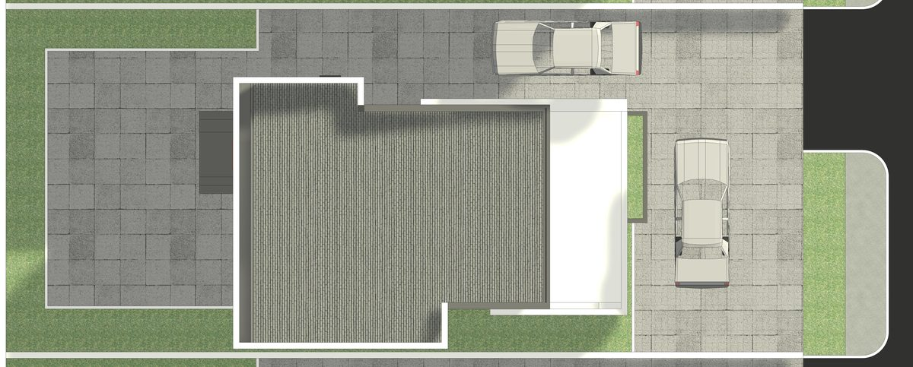
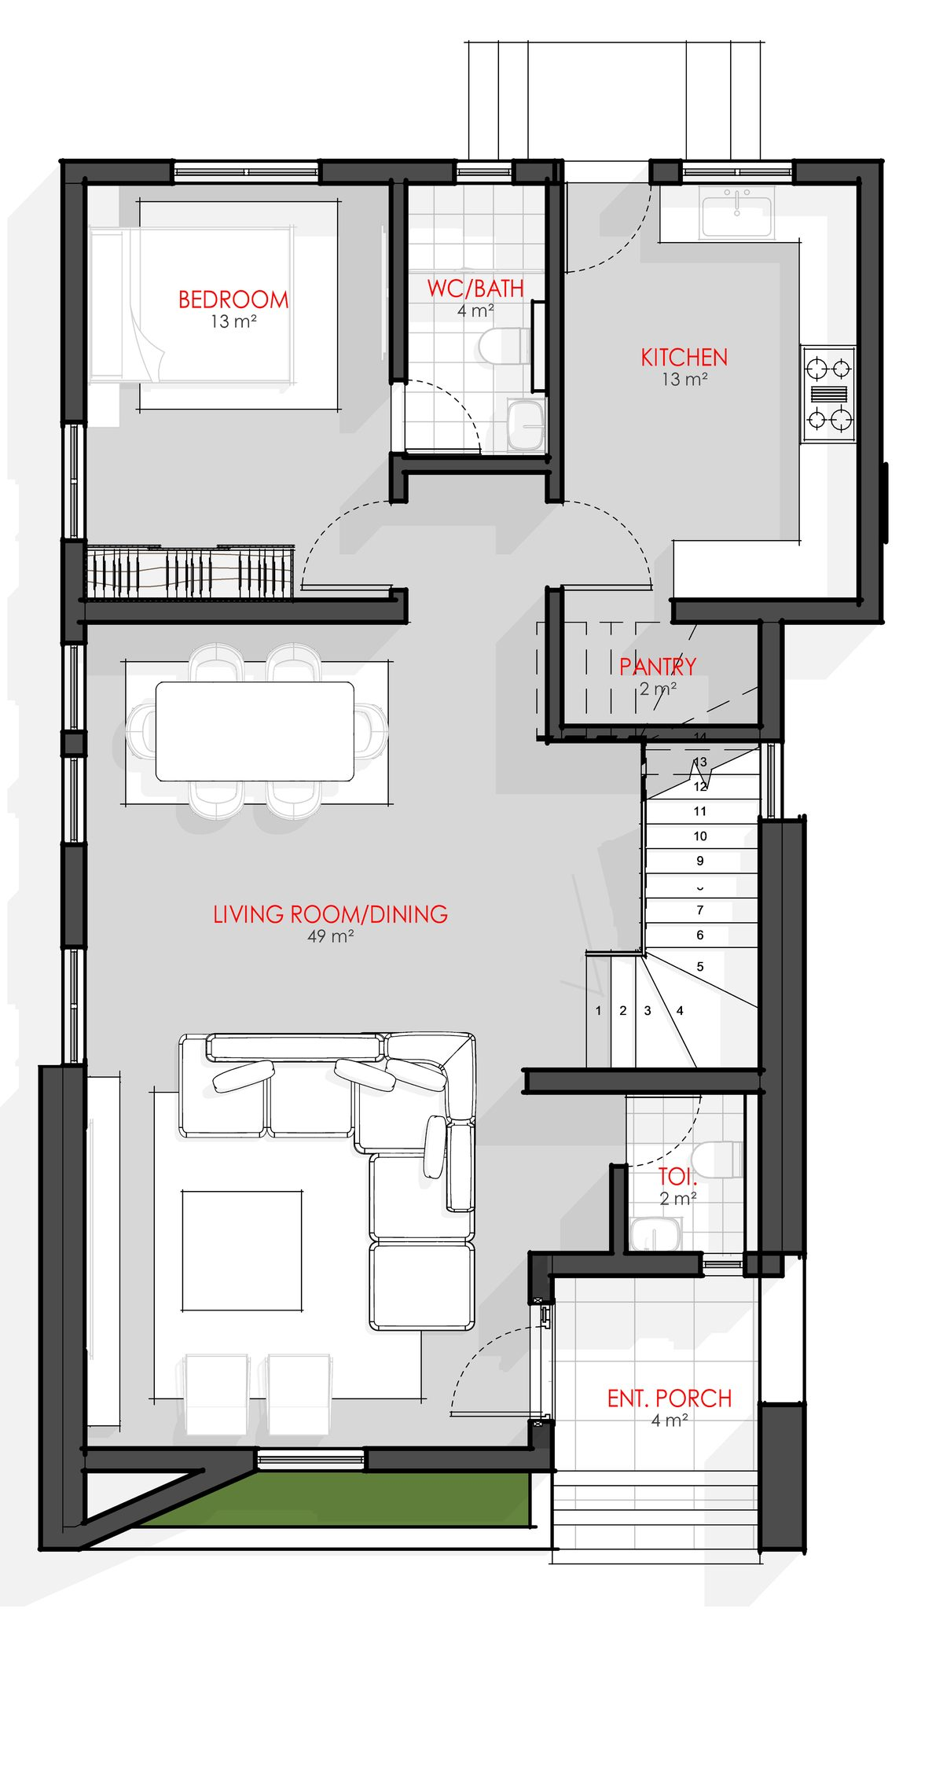 |  | 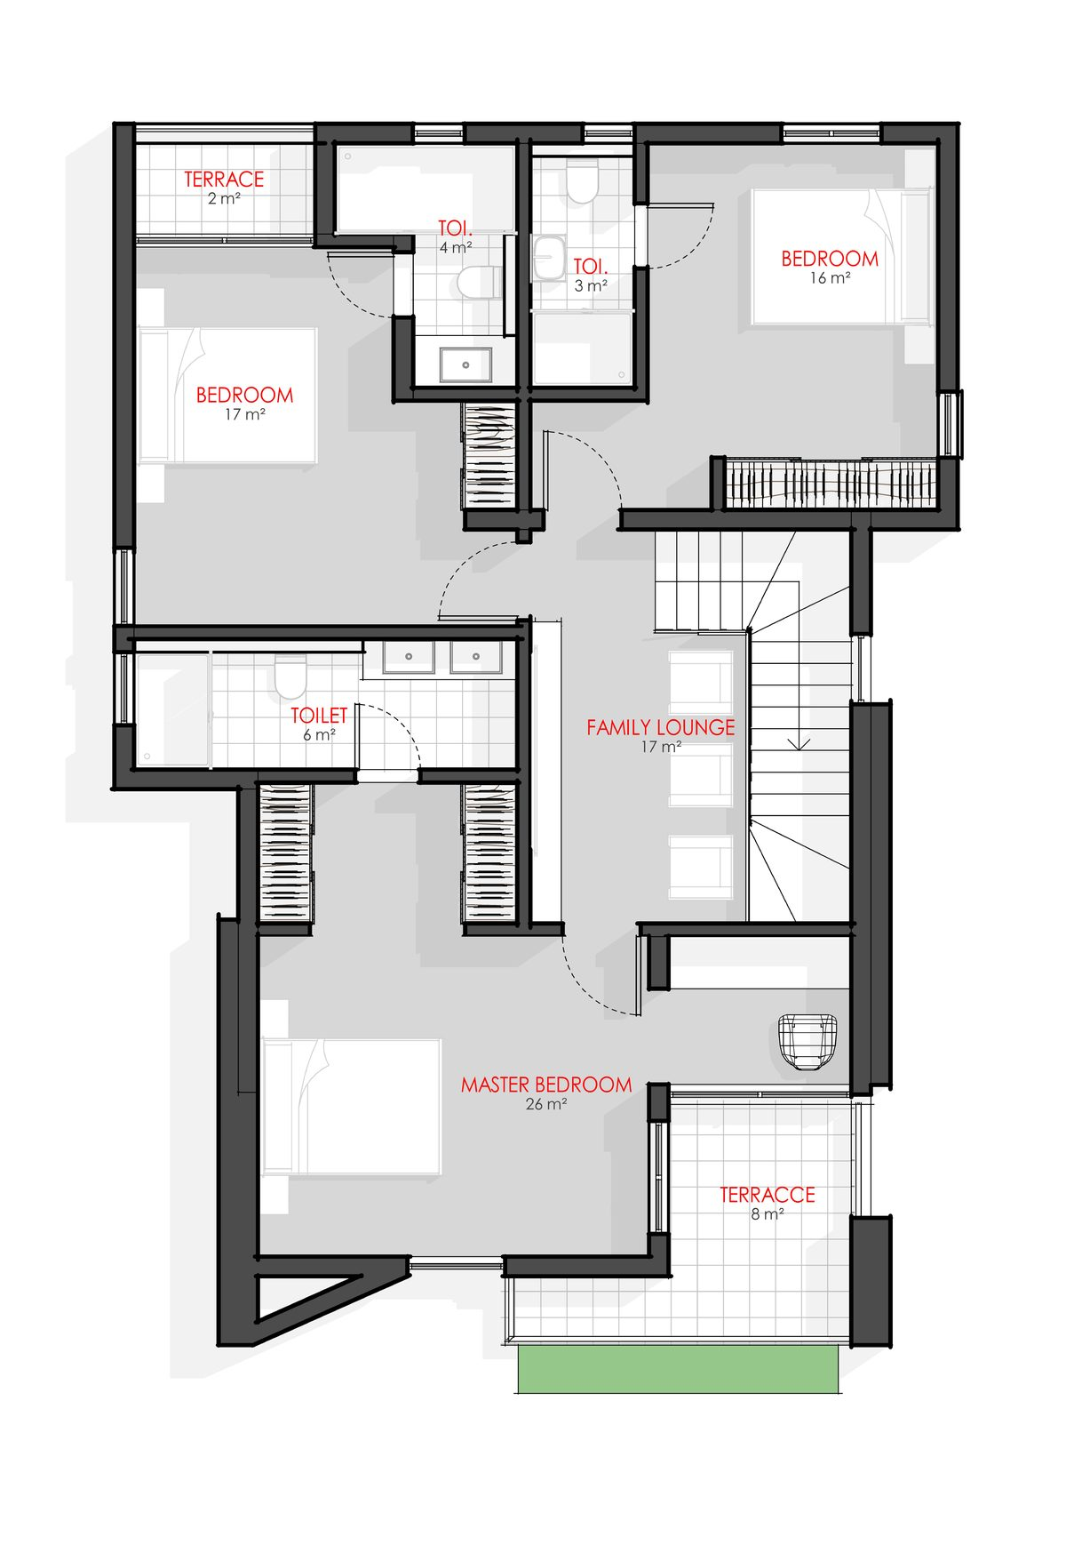

VISTAS 106 — PAPAL'S GROUND, KARSANA NORTH

Vistas 106 occupies a prime parcel at Papal's Ground in Karsana North — a rapidly appreciating district adjacent to Karsana's core estate belt. It offers the broadest unit-type mix in the Vistas range: from 2-bedroom apartments at ₦77M through to 4-bedroom detached duplexes with BQ at ₦220M, making it the most flexible entry point for investors across different capital budgets.

Karsana North benefits from infrastructure spillover from the established Karsana estate, while still offering lower entry prices than fully built-out sections. Investors at Vistas 106 are positioned to benefit from rental income and strong capital uplift as the district matures and land values converge with prime Karsana.

Location | Papal's Ground, Karsana North, Abuja
4 Bed Detached + BQ | ₦220,000,000
4 Bed Terrace Duplex | ₦165,000,000
3 Bed Apartment | ₦101,000,000 — Advanced Shell
2 Bed Apartment | ₦77,000,000 — Advanced Shell
Payment Bank | Providus Bank · 1300778295 · ONE SQUARE METER
Application Form | 106 FORM.pdf — in document folder

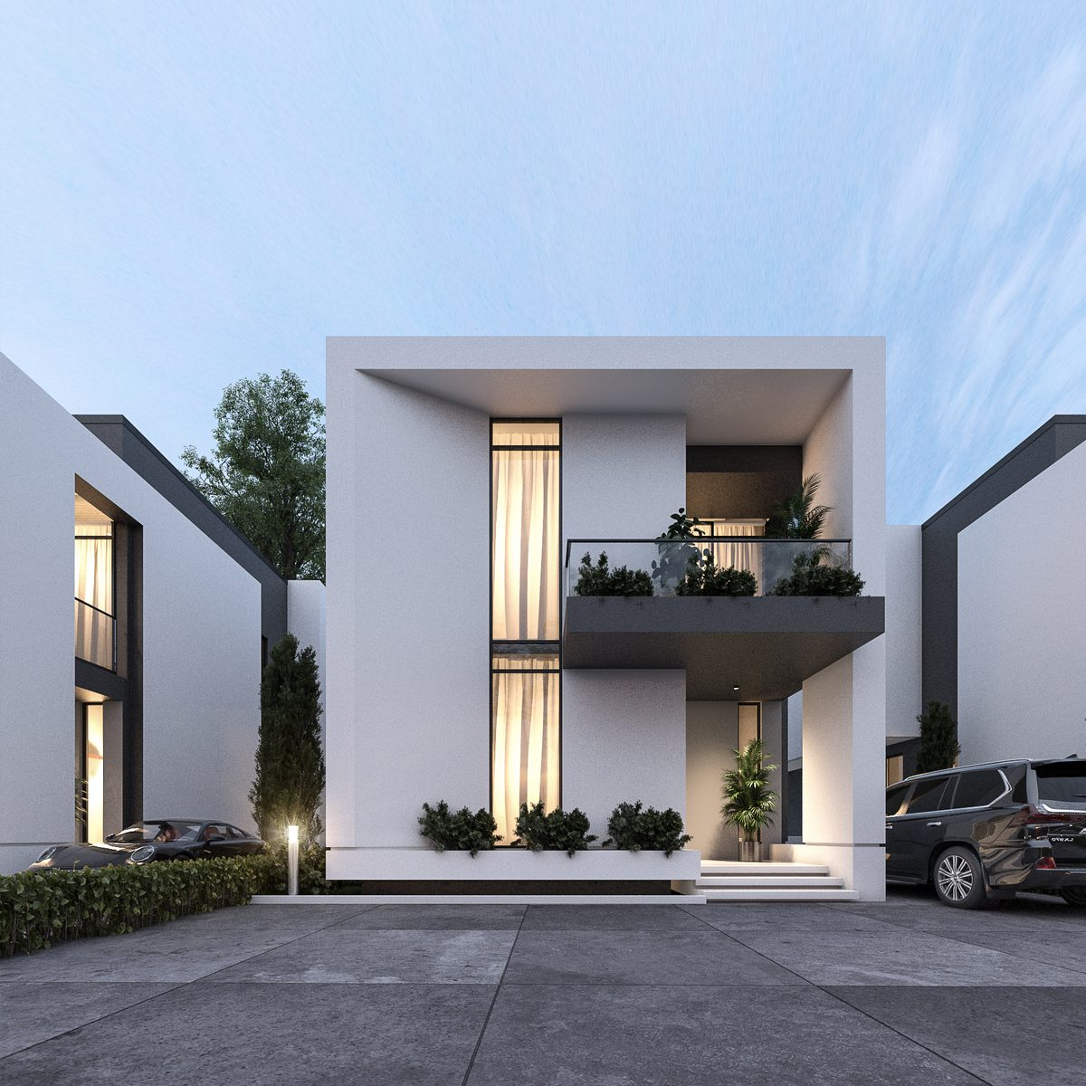 |  | 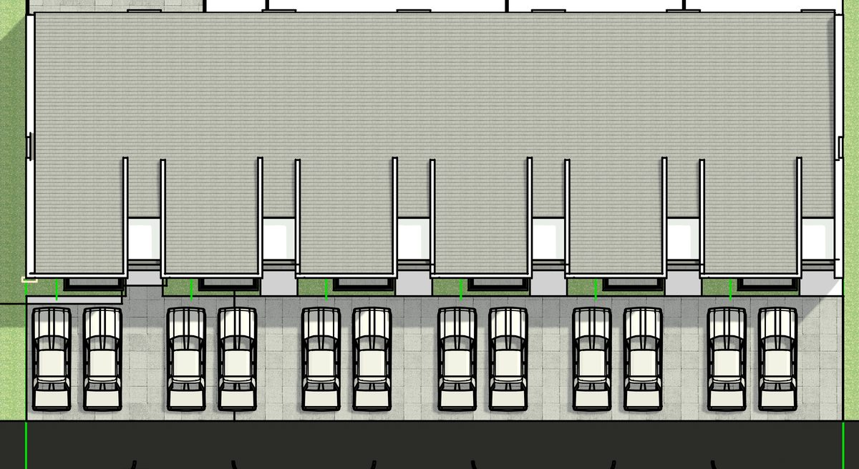
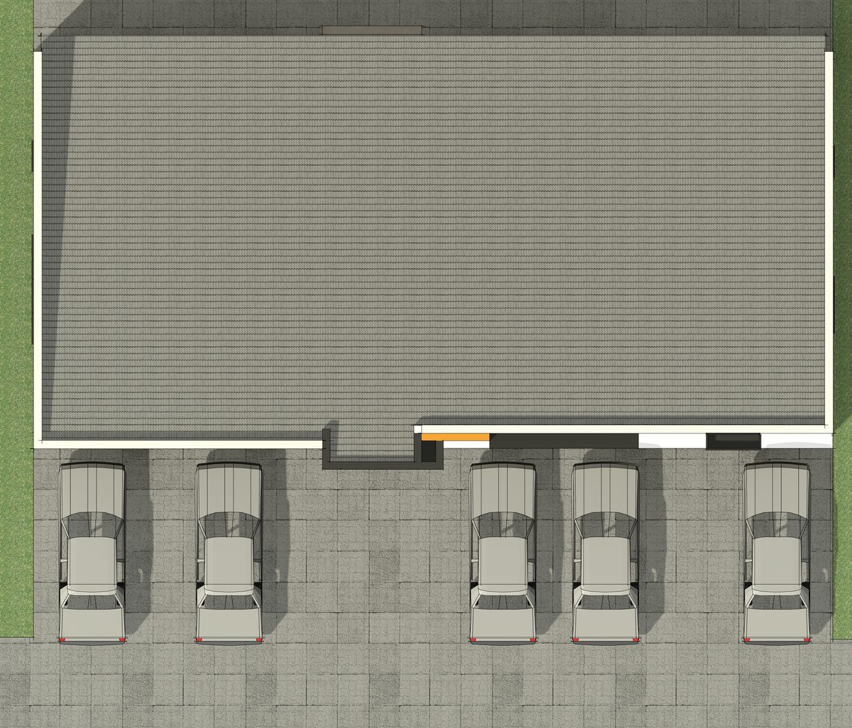
Floor Plans — 4 Bed Terrace
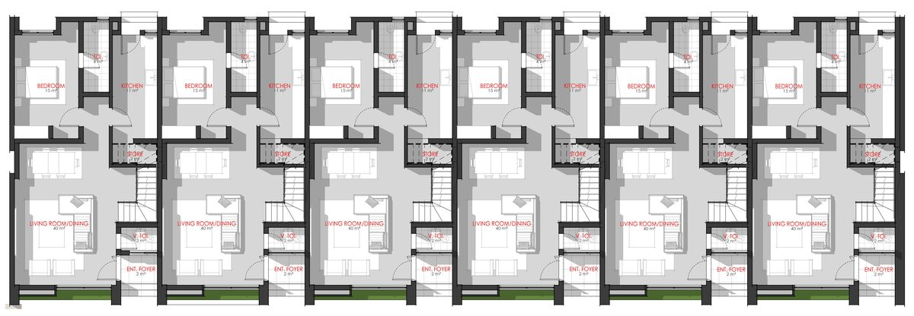 |  | 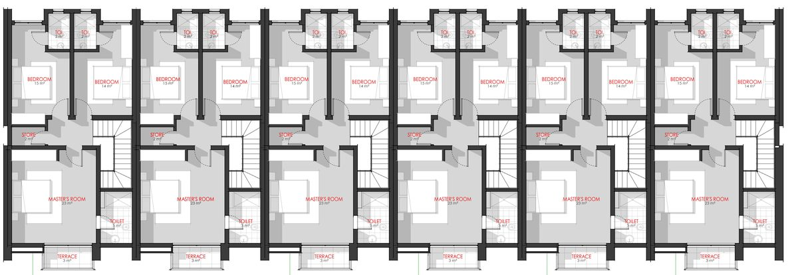
Floor Plans — Apartment
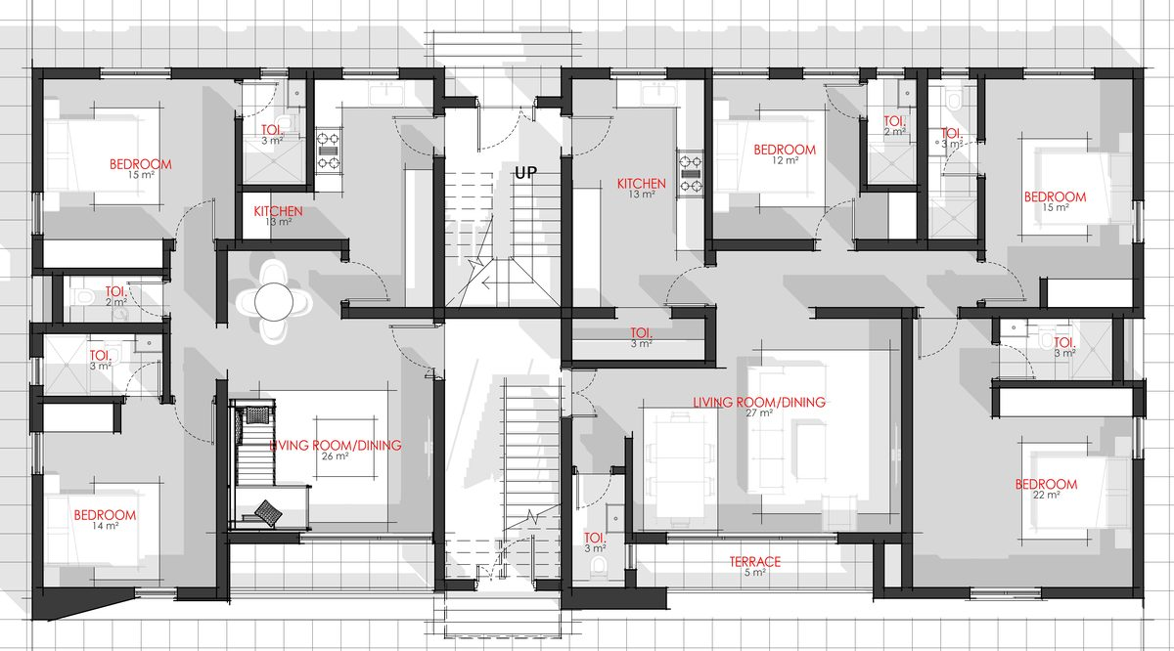 |  | 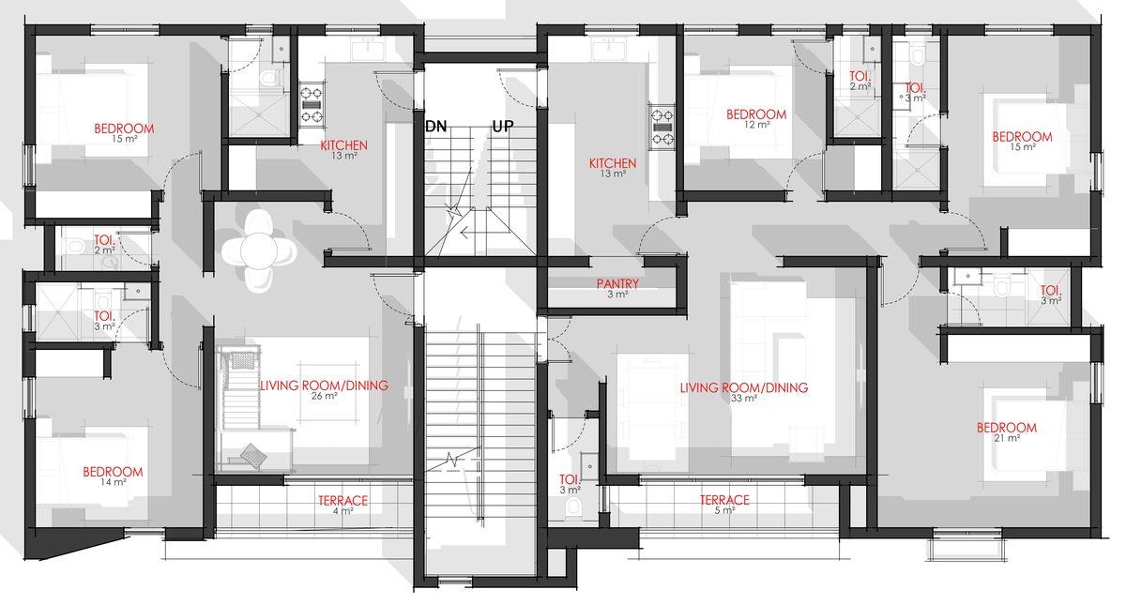

VISTAS 310 — NILE UNIVERSITY STREET, JABI

Vistas 310 is the Jabi flagship of the Dantata Vistas range — located on the prestigious Nile University Street, the same institutional corridor anchoring the Dantata Hostels project. Jabi is among Abuja's most sought-after residential addresses, combining proximity to the Wuse 2/Utako commercial spine with Jabi's own thriving retail and dining scene.

As the most centrally located Vistas project, 310 commands the highest prices in the range, reflecting Jabi's superior residential demand and the scarcity of development-ready land in the district. Investors at this project are acquiring in one of Abuja's most liquid residential markets — shorter resale timelines and broader rental demand than any other Vistas location.

Location | Nile University Street, Jabi (Institution & Research District), Abuja
4 Bed Detached + BQ | ₦265,000,000
4 Bed Terrace Duplex | ₦178,000,000
3 Bed Apartment | ₦115,000,000
2 Bed Apartment | ₦83,000,000
Payment Bank | Providus Bank · 1300778295 · ONE SQUARE METER
Application Form | 310 FORM.pdf — in document folder

 |  | 

Floor Plans — 4 Bed Terrace
 |  | 
Floor Plans — Apartment
 |  | 

VISTAS 2151 — BY KABUSA GARDENS, LOKOGOMA | Entry from ₦65M (DPC)

Vistas 2151 is the value-entry and highest-upside offering in the Dantata Vistas portfolio. Located by Kabusa Gardens in Lokogoma — one of Abuja's fastest-growing residential expansion zones — the project benefits from significant government and private infrastructure investment, including road upgrades and utility expansion.

Crucially, Vistas 2151 is the only 1SQM project where DPC-stage (Damp Proof Course) units are available. Investors can enter at the earliest construction stage from just ₦65,000,000 for a four-bedroom detached duplex, and benefit from the full capital uplift as the building is completed. This early-entry pricing creates one of the most attractive risk-adjusted investment propositions in the entire 1SQM portfolio. The Zenith Bank account (not Providus) is used exclusively for Vistas 2151 payments.

Location | By Kabusa Gardens, Lokogoma, Abuja (Sunnyvale Road)
4 Bed Detached — DPC | ₦65,000,000 (earliest construction stage)
4 Bed Detached — Shell | ₦210,000,000
4 Bed Terrace — Shell | ₦145,000,000
3 Bed Terrace — Shell | ₦115,000,000
3 Bed Apartment | ₦95,000,000 — Advanced Shell
2 Bed Apartment | ₦72,000,000 — Advanced Shell
Payment Bank | Zenith Bank · 1015923218 · ONE SQUARE METER (unique to Vistas 2151)
Application Form | 2151 FORM.pdf — in document folder

 |  | 

Floor Plans
 |  | 

Vistas Consolidated Pricing — February 2026

Project | 4 Bed Detached | 4 Bed Terrace | 3 Bed Apt | 2 Bed Apt
Vistas 2151 (Lokogoma) | ₦65M DPC / ₦210M Shell | ₦145M (Shell) | ₦95M (Adv Shell) | ₦72M (Adv Shell)
Vistas 106 (Karsana N) | ₦220,000,000 | ₦165,000,000 | ₦101,000,000 | ₦77,000,000
Vistas 310 (Jabi) | ₦265,000,000 | ₦178,000,000 | ₦115,000,000 | ₦83,000,000

DANTATA ARCADE
EFAB Queens Gate, Karsana, Abuja · Commercial Units

COMMERCIAL OVERVIEW

Dantata Arcade is 1SQM's commercial real estate offering — a purpose-built retail and commercial arcade within EFAB Queens Gate in Karsana. The project serves the growing resident population of the estate and its surroundings, providing anchor commercial tenants and smaller retail operators with purpose-built, high-specification units.

Four unit typologies cater to the full spectrum of commercial demand: compact 50sqm duplex shops for boutiques and service businesses, mid-range 75sqm triplex shops for restaurants and showrooms, and large-format 125–300sqm units with dedicated lounge areas for anchor tenants such as banks and supermarkets. All units are delivered at Advanced Shell stage — structurally complete and ready for fit-out.

Commercial real estate in Abuja's growing suburban estates commands strong rents driven by captive residential demand. The EFAB Queens catchment is an established, high-density cluster providing an immediate and growing customer base for Arcade tenants from day one.

Location | EFAB Queens Gate, Karsana, Abuja
Development | Purpose-built retail and commercial arcade
Delivery Stage | Advanced Shell — structurally complete, ready for fit-out
Unit Types | Type A (75sqm Triplex) · Type B (50sqm Duplex) · Type C (150sqm + Lounge) · Type D (125sqm + Lounge)
Payment Bank | Providus Bank · 1300778295 · ONE SQUARE METER
Application | EFAB FORM.pdf — in document folder

TYPE B — 50 SQM DUPLEX SHOP | ₦100,000,000

The 50sqm Duplex Shop is the entry-level commercial unit, spanning two floors with a compact 50sqm ground-floor footprint. Ideally suited for boutique retail, pharmacy, telecoms, food service, or professional services. The duplex configuration allows the upper floor to serve as storage, a staff area, or a service counter extension, giving operators maximum flexibility within a modest footprint.

Type | Type B — Duplex Shop
Gross Area | 50 sqm (2 floors)
Configuration | Ground floor retail + First floor
Ideal Tenants | Boutique retail · Pharmacy · Telecoms · Food service · Professional services
Delivery | Advanced Shell
Price | ₦100,000,000

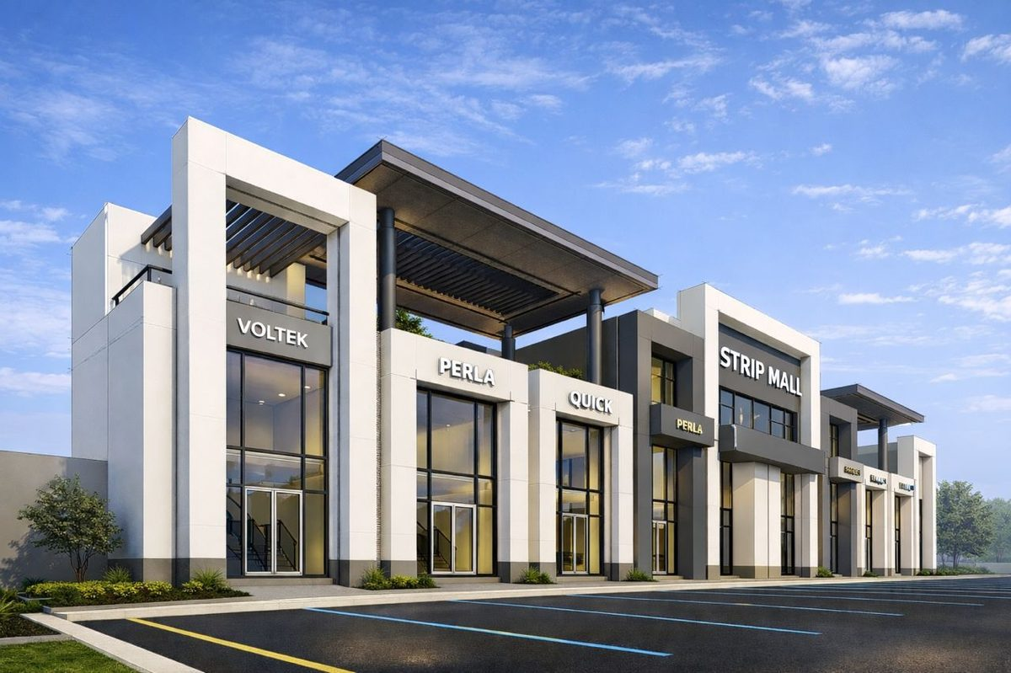
Floor Plans — 50sqm Duplex
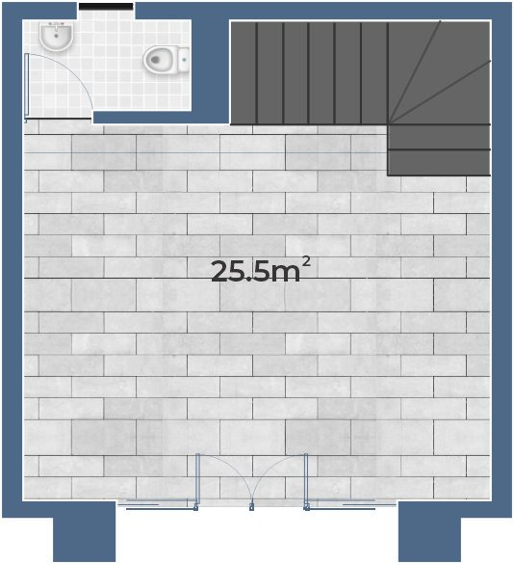 |  | 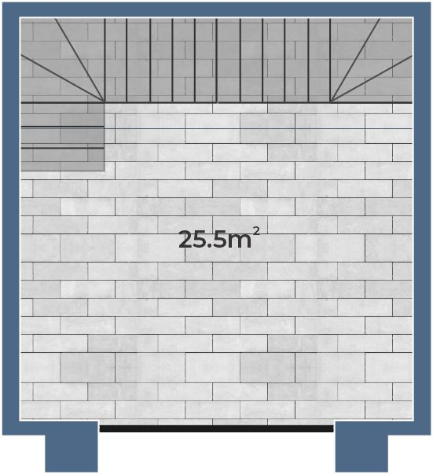

TYPE A — 75 SQM TRIPLEX SHOP | ₦135,000,000

The 75sqm Triplex Shop is the mid-range commercial unit offering three full floors of commercial space. The largest floor-area-per-unit in the standard range, this unit suits higher-volume operations that benefit from vertical expansion: restaurants with upstairs dining, showrooms, or service businesses with front-of-house and back-of-house separation. Three floors across a 75sqm footprint delivers effectively 225sqm of total useable floor area.

Type | Type A — Triplex Shop
Gross Area | 75 sqm per floor · 3 floors
Configuration | Ground + First + Second floor
Ideal Tenants | Restaurant · Showroom · Multi-floor retail · Service business
Delivery | Advanced Shell
Price | ₦135,000,000


Floor Plans — 75sqm Triplex
 |  | 
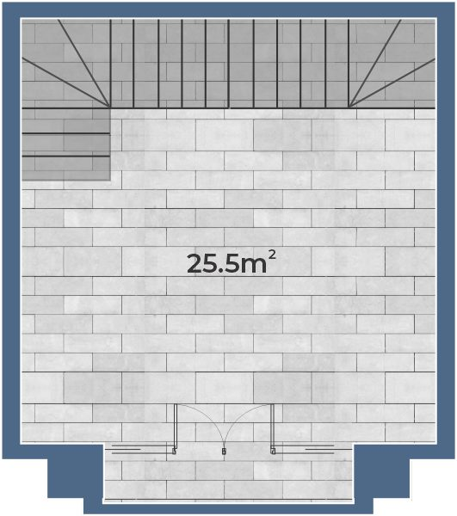

TYPE C & D — BANKING HALL / SUPERMARKET | ₦117.5M – ₦165M

Types C and D are the anchor tenant units — large-format commercial spaces with dedicated lounge areas, designed for banks, supermarkets, pharmacies, restaurants, or high-footfall retailers. Type C is a three-storey Triplex with ground-floor lounge (150sqm total). Type D is a two-storey Duplex with lounge (125sqm total). Both unit types are particularly attractive to financial institutions and FMCG retailers seeking a purpose-fitted space in a captive residential catchment with guaranteed daily footfall.

Type C | Triplex + Lounge · 150 sqm total · ₦165,000,000
Type D | Duplex + Lounge · 125 sqm total · ₦117,500,000
Lounge | Dedicated customer-facing lounge included in both types
Ideal | Banks · Supermarkets · Pharmacies · Restaurants · Showrooms
Delivery | Advanced Shell — ready for full fit-out



Arcade Unit Comparison

Unit Type | Configuration | Area | Stage | Price
Type A — Triplex | 3 Floors | 75 sqm | Advanced Shell | ₦135,000,000
Type B — Duplex | 2 Floors | 50 sqm | Advanced Shell | ₦100,000,000
Type C — Triplex + Lounge | 3 Floors + Lounge | 150 sqm | Advanced Shell | ₦165,000,000
Type D — Duplex + Lounge | 2 Floors + Lounge | 125 sqm | Advanced Shell | ₦117,500,000

PRICING & APPLICATION GUIDE
All Prices Effective February 2026

Complete Pricing Reference

All prices are in Nigerian Naira (₦). Subject to change — confirm current pricing with the 1SQM sales team before submitting an application.

Dantata Hostels — Hostel 747, Jabi (Fully Furnished)

Unit Type | Furnishing | Price
4 Bedroom Terrace Duplex | Fully Furnished | ₦300,000,000
3 Bedroom Terrace Duplex | Fully Furnished | ₦225,000,000
2 Bedroom Apartment | Fully Furnished | ₦150,000,000
1 Bedroom Apartment (Gold) | Fully Furnished | ₦112,500,000
1 Bedroom Apartment (Plat) | Fully Furnished | ₦115,000,000
Studio Apartment | Fully Furnished | ₦50,000,000

Dantata Vistas — All Locations

Project | Unit Type | Stage | Price
Vistas 2151 (Lokogoma) | 4 Bed Detached + BQ | DPC | ₦65,000,000
Vistas 2151 (Lokogoma) | 4 Bed Detached + BQ | Shell | ₦210,000,000
Vistas 2151 (Lokogoma) | 4 Bed Terrace Duplex | Shell | ₦145,000,000
Vistas 2151 (Lokogoma) | 3 Bed Terrace Duplex | Shell | ₦115,000,000
Vistas 2151 (Lokogoma) | 3 Bed Apartment | Adv. Shell | ₦95,000,000
Vistas 2151 (Lokogoma) | 2 Bed Apartment | Adv. Shell | ₦72,000,000
Vistas 106 (Karsana N) | 4 Bed Detached + BQ | — | ₦220,000,000
Vistas 106 (Karsana N) | 4 Bed Terrace Duplex | — | ₦165,000,000
Vistas 106 (Karsana N) | 3 Bed Apartment | — | ₦101,000,000
Vistas 106 (Karsana N) | 2 Bed Apartment | — | ₦77,000,000
Vistas 310 (Jabi) | 4 Bed Detached + BQ | — | ₦265,000,000
Vistas 310 (Jabi) | 4 Bed Terrace Duplex | — | ₦178,000,000
Vistas 310 (Jabi) | 3 Bed Apartment | — | ₦115,000,000
Vistas 310 (Jabi) | 2 Bed Apartment | — | ₦83,000,000

Dantata Arcade — EFAB Queens Gate, Karsana

Unit Type | Configuration | Area | Stage | Price
Type A — Triplex | 3 Floors | 75 sqm | Adv. Shell | ₦135,000,000
Type B — Duplex | 2 Floors | 50 sqm | Adv. Shell | ₦100,000,000
Type C — Triplex + Lounge | 3 Floors + Lounge | 150 sqm | Adv. Shell | ₦165,000,000
Type D — Duplex + Lounge | 2 Floors + Lounge | 125 sqm | Adv. Shell | ₦117,500,000

HOW TO APPLY

Step 1 — Select your property and unit type from the pricing tables above.

Step 2 — Download the application form for your chosen project:

- Dantata Hostels (747): 747 Application Form.pdf
- Vistas 106 (Karsana North): 106 FORM.pdf
- Vistas 310 (Jabi): 310 FORM.pdf
- Vistas 2151 (Lokogoma): 2151 FORM.pdf
- EFAB Arcade (Karsana): EFAB FORM.pdf

Step 3 — Complete the form in block capital letters. Attach two recent passport photographs.

Step 4 — Make payment to the appropriate bank account:

- Providus Bank · 1300778295 · ONE SQUARE METER (all projects except Vistas 2151)
- Zenith Bank · 1015923218 · ONE SQUARE METER (Vistas 2151 only)

Step 5 — Attach a copy of your payment teller/transfer confirmation to the completed form and submit to the 1SQM Project Office.

Step 6 — Await your allocation letter. Note: submission of an application form does not guarantee allocation.

CONTACT & ENQUIRIES

Phone | 0902 002 0077
Website | 1sqmbydantata.com
Email | tosin.bolaji@1sqmbydantata.com
Address | ONE SQUARE METER BY DANTATA LTD, Abuja, Federal Capital Territory, Nigeria

READY TO OWN YOUR FUTURE?
Call 0902 002 0077 to reserve your unit today.
Prices effective February 2026 · Subject to change · All figures in Nigerian Naira (₦)

